**CHAKRA IT SOLUTIONS**

whatsapp_PNG4.png **: 9505 233 545, ✆ :87 1255 1199, 040-64551199**

**JNTU KUKATPALLY | AMEERPET**

**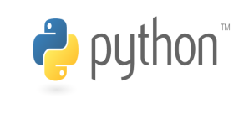­­­­­­­­­­­­­­­­­­­­**

**Python Course Content**

**Introduction to Python Programming**

**Trainer Name : Venkat**

**Total Exp : 14 years**

**Relevant Exp : 7+ years**

**No of Days Training : 30 days (45 Hours)**

**Project : Yes**

**Fee :**

* **Why Python?**
* [**Pre-requisites**](https://nareshit.in/python-training/#What_are_the_Python_Course_Pre-requisites) **to learn Python**
* [**Course**](https://nareshit.in/python-training/#Objectives_of_the_Course) **Objective**
* **Course Duration & Plan**

**About Python and Setup**

* **Python History**
* **Python Features/Advances**
* **Python Environments setup.**
* **IDE setup (Anaconda/PyChamp)**

**Python rules and Identifiers**

**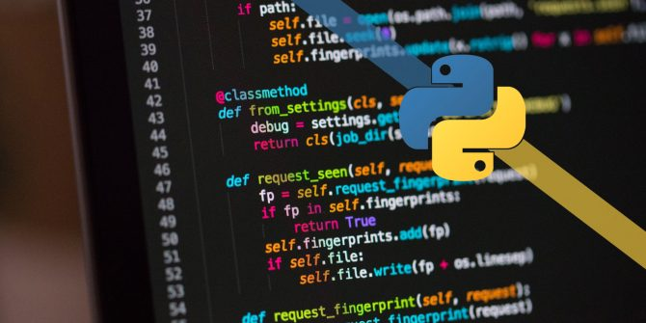**

* **Coding rules**
* **Assignment types, comment, continue**
* **Other basics rules and Identifiers.**

**Data Types and Operations/Functions**

**on Data Types**

* **Numbers**
* **Strings**
* **List**
* **Tuple**
* **Dictionary**
* **Sets**
* **Boolean**

**Python Operators**

* **Arithmetic Operators**
* **Comparison Operators**
* **Assignment Operators**
* **Bitwise Operators**
* **Logical Operators**
* **Identity Operators**
* **Membership Operators.**

**Decision Making**

* **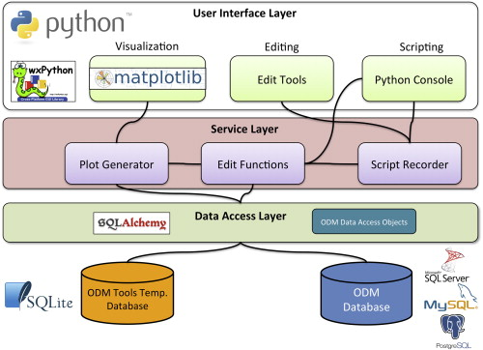Different types of If conditions**
* **if**
* **if-- else**
* **if--elif**
* **if--elif—else**
* **Nested if conditions**

**Loops**

* **Different types of Loops in Python.**
* **While**
* **For**
* **Nested loops**
* **Break, Pass, Continue etc.**

**Data type conversions**

* **Data Type conversions**
* **Numeric to string**
* **Strings to numeric**
* **List to tuple**
* **Tuple to list**
* **And all other possible conversions**

**Functions in Python**

* **Function definition**
* **Function Objects**
* **Function Callings**
* **Arguments passing to Function**
* **Returning value from function**
* **\*args & \*\*kwargs**
* **Anonymous Function & others -**
* **Lambda**
* **Map**
* **Filter**
* **Reduce, etc.**

**Modules and Packages**

* **Module Creations and Usage**
* **Package Creation and Usage**

**File Handling**

* **Operations on files - Create, Read, Edit, Append, Delete, Write, Close, etc..**
* **All Useful functions/operations on files**

**Work with database**

* **Connecting with Database.**
* **Database Operations**
* **Database Connection**
* **Create Database**
* **Working on DML and DDL statements.**

**OOPs Concepts & Other topics**

* **Classes**
* **Objects / Instances**
* **methods & method calls**
* **Inheritance**
* **Encapsulation/Abstraction /Data or Method hiding**
* **Polymorphism**
* **Operator Overloading**
* **Method Overloading**
* **Method Overriding**

**Exception Handling in Python Programming**

* **Default Exception Handler**
* **Catching Exceptions**
* **Raise an exception**
* **User define exceptions**

**Multithreading and Multiprocessing**

* **Introduction to Threads in python**
* **Multithreading**
* **Multiprocessing**

**Python Packages**

* **Pandas**
* **Numpy**
* **Matplotlib/Seaborn**
* **Time**
* **Calendar**
* **Scipy**
* **Sklearn.**
* **And other important packages**

**Other topics in Python**

* **Decorators for method and class**
* **Generators**
* **Iterators**
* **Duck Typing**
* **Monkey Patching in Python**
* **Shallow copy and deep copy**
* **Mail sending from Python**
* **Other important concepts in python**

**Highlights**

* **Introduction for Data Science and Machine learning**
* **Introduction on Web development/Django with python scripts**
* **Daily Practice with topic level exercises**
* **Mini Project**
* **Provide Python material (PPTs and Topic wise codes)**
* **Sessions on Interview questions.**
* **Sessions on resume preparatio****n.**
* **Mock interviews and job assistance.**